Logging Sensor Data from the Sensor Shield using the Arduino Uno

SENSORSHLD1-EVK-101 and the Arduino Uno

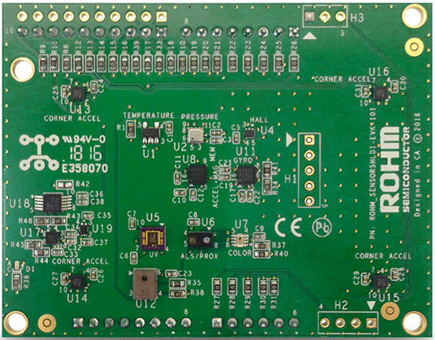

Above: Top view of ROHM SENSORSHLD1-EVK-101

10 November 2016, Revision A

# Introduction

The following document was written to provide an explanation of how to log sensor data using the Arduino example application provided in this repository. Supplementary information including application examples and HW design files for this board can be found at the following repository link.

ROHM’s Multi-Sensor Shield GitHub Repository Page: <https://github.com/ROHMUSDC/ROHM_SensorPlatform_Multi-Sensor-Shield>

ROHM’s SENSORSHLD1-EVK-101 is a shield evaluation platform that connects all ROHM sensor products onto a single board. This shield uses standard Arduino shield interface pins; therefore, can connect to any evaluation kit that has a shield interface header. The shield contains the following sensors:

* Core Sensors:
  + ROHM BDE0600G – Analog Temperature Sensor
  + ROHM BM1383AGLV – Digital Barometric Pressure Sensor
  + ROHM BU52014HFV – Hall Switch Sensor (Omnipolar with Polarity Discrimination)
  + ROHM BM1422GMV – Magnetometer Sensor
  + KIONIX KX122 – Digital Accelerometer
  + KIONIX KMX62 – Digital Magnetometer and Accelerometer
  + KIONIX KXG03 – Digital Gyroscope and Accelerometer
  + LAPIS ML8511A – Analog UV Sensor
  + ROHM RPR-0521 – Digital Ambient Light Sensor and Proximity Sensor
  + ROHM BH1745 – Digital Color Sensor
* Special Functions:
  + KNOWLES SPM0423HD4H-WB – Digital Microphone
    - Primarily for use with NXP MCU Lineup
  + KIONIX KX122-1037, KX122-1048 – Accelerometer
    - For four corner Accelerometer algorithm development
    - Difference between 1037 and 1048 is the I2C register address scheme to control all 4 accelerometers using a single I2C master

# Prerequisites

Please review “ROHM_SENSORSHLD1-EVK-101_ArduinoUsageManual_2016-10-20.pdf” and “ROHM_SENSORSHLD1-EVK-101_PlatformGuide_Arduino_2016-10-20.pdf” before proceeding

This document assumes that you have completed the following:

1. Installation of the Arduino IDE and import of the SoftI2CMaster Library
2. Download and Flashed the Example Code from the Shield GitHub Repository
3. Perform the necessary HW rework for running the Sensor Shield with the Arduino UNO
4. Installed TeraTerm and successfully output demo data

# How to Log Sensor Shield Data From the Arduino Uno

1. Open the sample code for the Sensor Shield within the Arduino IDE
   1. Filename: ROHM_SENSORSHLD1-EVK-101_TerminalDemo_11-10-2016.ino
   2. Location in GitHub Repository: ..\ROHM_SensorPlatform_Multi-Sensor-Shield\Platform Code\Arduino_UNO_FirmwareExample\ROHM_SENSORSHLD1-EVK-101_10-20-2016\ROHM_SENSORSHLD1-EVK-101_TerminalDemo_11-10-2016
2. Scroll down to the “Demo Mode Definitions Section
   1. 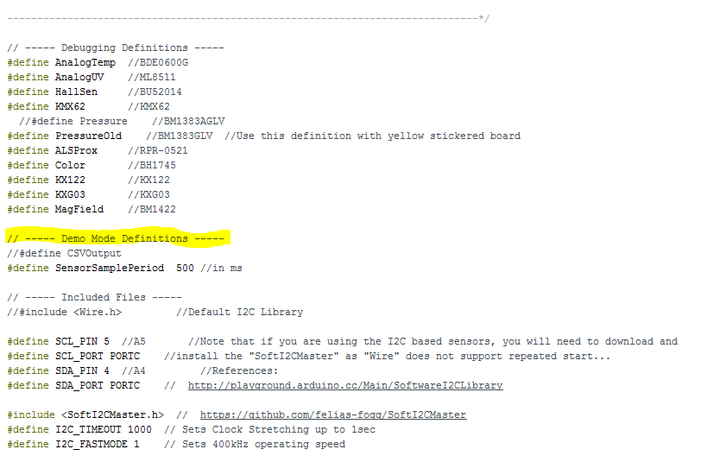
3. Uncomment the line “//#define CSVOutput”
   1. 
4. Flash the application into the Arduino UNO using the Upload button
5. Open Tera Term
6. Connect via Serial Port Connection to the Arduino Uno
   1. 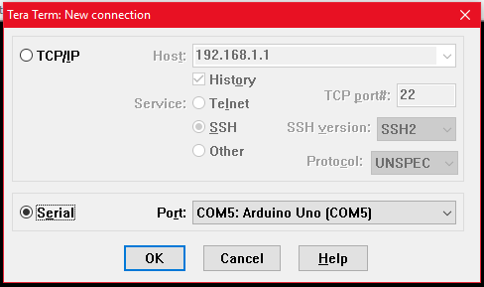
7. Adjust the Serial Port Baud Rate by going into Setup -> Serial Port Menu
8. Change the Baud Rate to 115200 and click OK
   1. 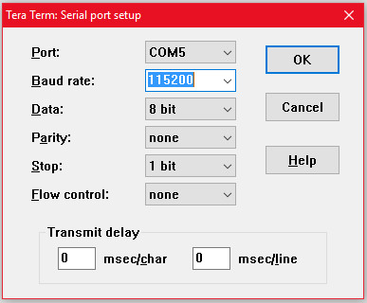
9. Now, the terminal should be Open and streaming back long lines of data. See below for an example picture
   1. 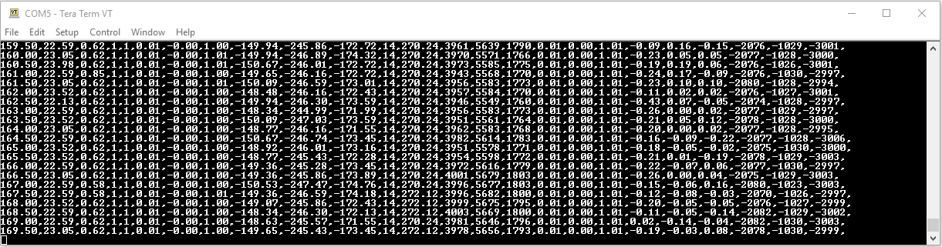
10. When you are ready to begin logging, in Tera Term, go to File -> Log..
11. This will open a window prompting where it should save this log file. Choose a destination and name for your log file. Click “Save” when completed.
    1. NOTE: save the log file as a *.csv at this step to save the trouble of renaming the file later
    2. 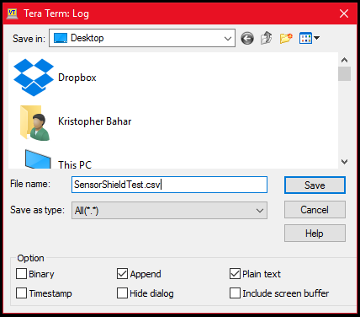
12. From the point when you saved the file, Tera Term will begin logging the sensor data output returning from the Arduino Uno. There will be another Tera Term window open where you can view the status of the log, including the Filename, Fullpath, and Bytes Transferred.
    1. 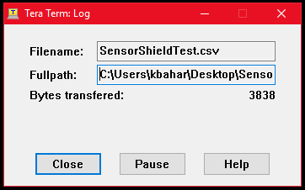
13. Reset the board using the RESET PB on the Arduino board. This will allow you to CSV Data header into your logging data set
    1. 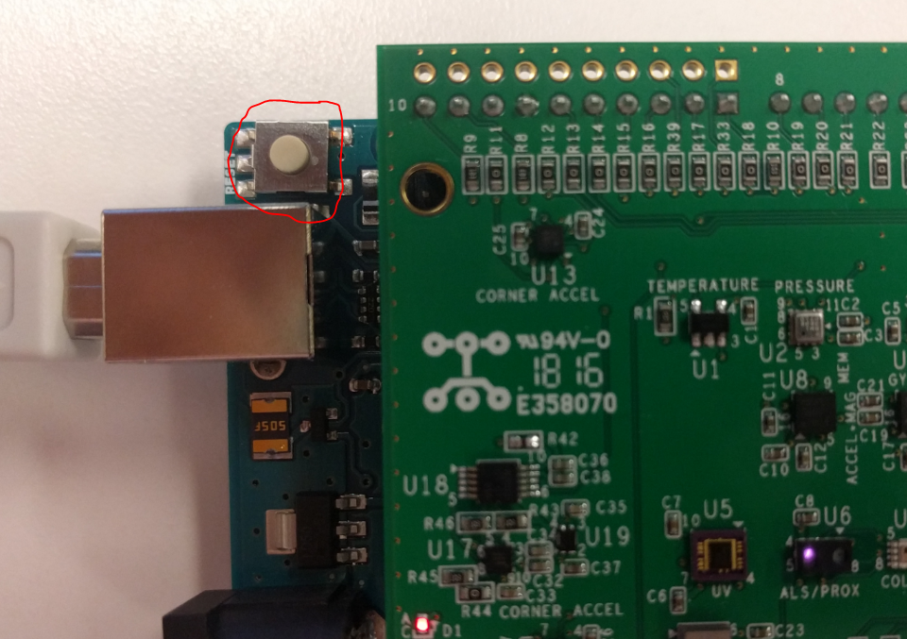
14. When you are done capturing your data, click the close button in the “Tera Term: Log” window
15. Next, we want to check the data. Open the CSV file in Excel or any other editing tool that you like
16. Delete all the rows leading up to the Header line. You can determine the header line as it is the line with the text explaining what the data of each column represents.
17. Now you’re done! Do whatever you want to the data!
    1. 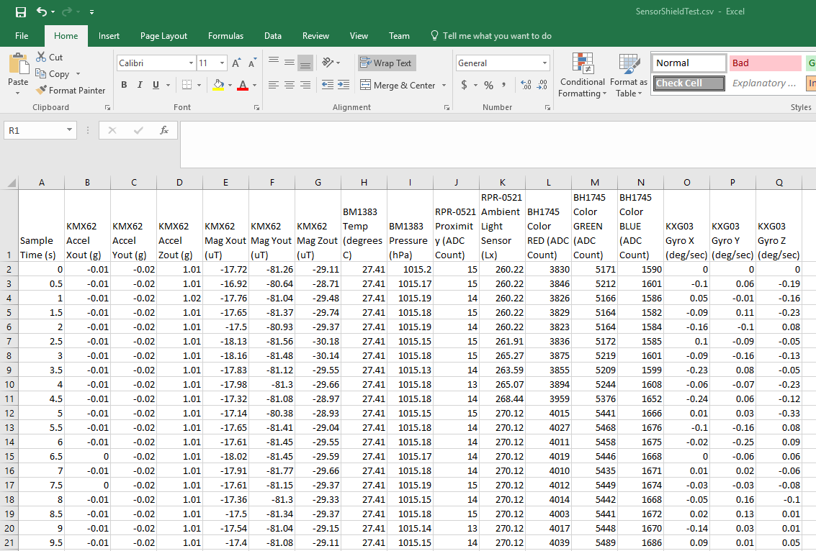
    2. TIP: if using a scatterplot, use the sample time column (column A) on the X axis and the sensor data on the Y axis.